Setting Up Application Environment

Create IBM Cloud Account

|  |  |
| --- | --- |
| Date | 24 OCT 2022 |
| Team ID | PNT2022TMID22955 |
| Project Name | Skill and Job Recommender Application |
| Team Members: | Keerthana C,Harisudhan J,Kavin Prakash S,Abishek S |

# Step 1:

Type or click the below link in the browser [***https://www.ibm.com/academic/home***](https://www.ibm.com/academic/home)

# Step 2:

Click register icon and give all the details one by one,

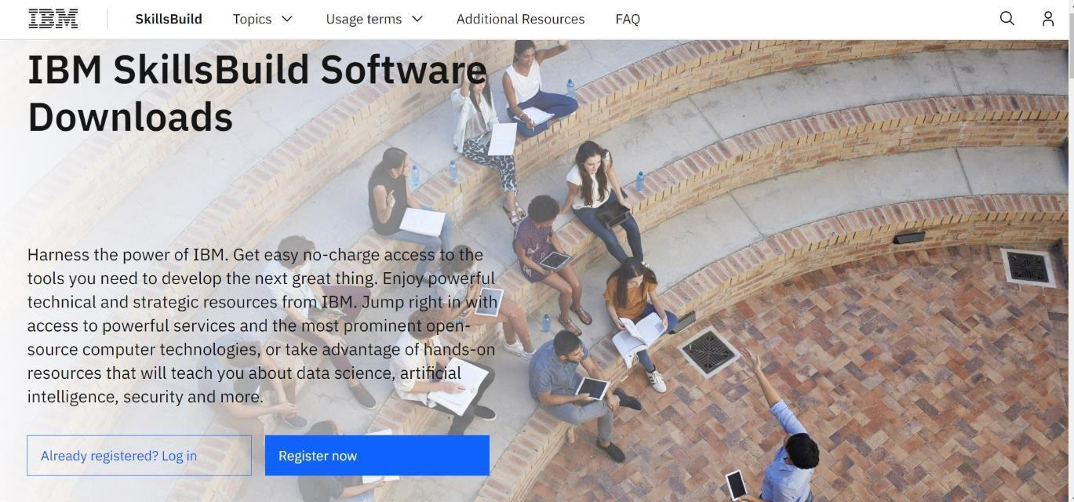

# Step 3:

Already you got SI EMAIL and SI PASSWORD from your IBM student login. Login to your web mail account. Wait for 7-digit verification code in your web mail:

***https://sg2plmcpnl496936.prod.sin2.secureserver.net:2096/***

# Step 4:

Get 7-digit verification code in webmail, then go to registration page and enter the

verification code.

# Step 5:

Now, you have successfully created the IBM Cloud Account.

# Step 6:

Go to IBM Cloud login page: [***https: //cloud.ibm.com/login***](https://cloud.ibm.com/login) ,then enter your IBM Id

and Password.

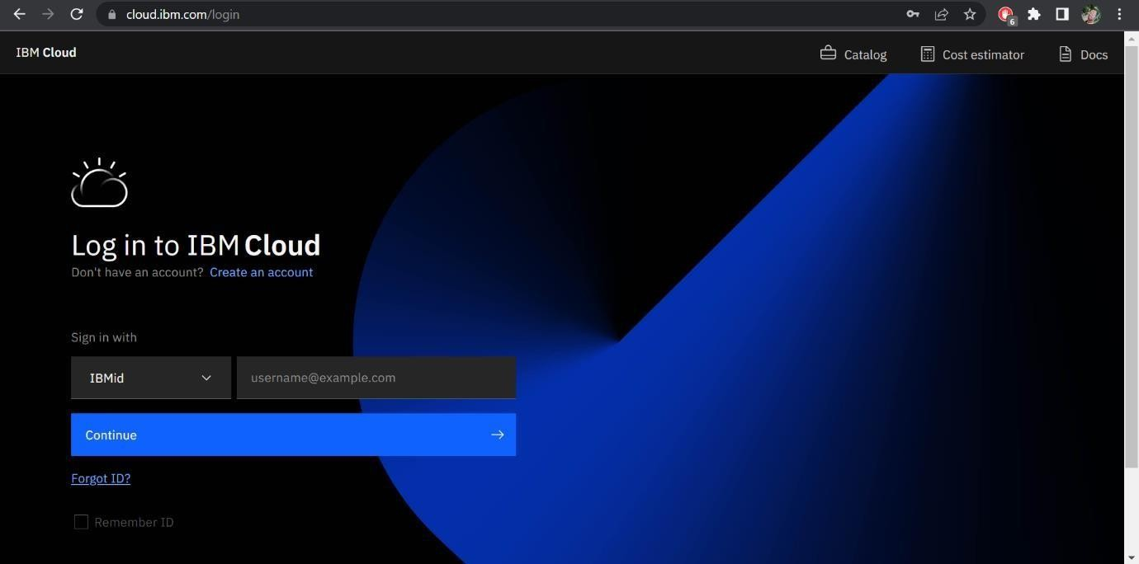

# Step 7:

Finally, you will access the IBM cloud account.

